**Problem 1.** The ABC Car Service & Repair Centers are owned by the Silent Car Dealership; ABC services and repairs only silent cars. Three ABC centers provide service and repair for the entire state.

Each of the three centers is independently managed and operated by a shop manager, a receptionist, and at least eight mechanics.

Each center maintains a fully stocked parts inventory. Each center also maintains a manual file system in which each car’s maintenance history is kept: repairs made, parts used, costs, service dates, owner, and so on. Files are also kept to track inventory, purchasing, billing, employees’ hours, and payroll.

You have been contacted by one of the center’s managers to design and implement a computerized database system. Given the preceding information, do the following:

**a. Indicate the most appropriate sequence of activities by labeling each of the following steps in the correct order. (For example, if you think that “Load the database” is the appropriate first step, label it “1.”)**

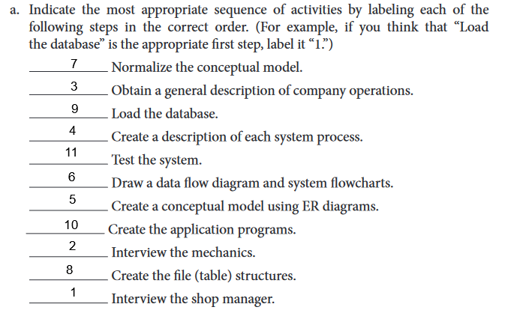

**b. Describe the various modules that you believe the system should include.**

**Answer :**

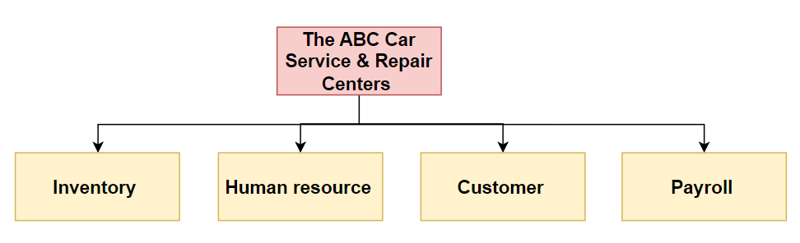

We believe that with the details of problem 1, there are 4 module must-have in this computerized database system respectively :

1. **Inventory Management –** This module will form the database model for handling store inventory. Any item inventory information will be collected by the database to better manage the product.

2. **Human resource –** This module would hold the information related to all the mechanics, manager and other employees that are working for the company.

3. **Customer Management –** This module would keep the information about the customer like his name, purchase item, price, previous services & purchases etc

4. **Payroll –** The payroll would have the information about all the employees and their salaries.

**Compare with ChatGPT :**

**Answer :**

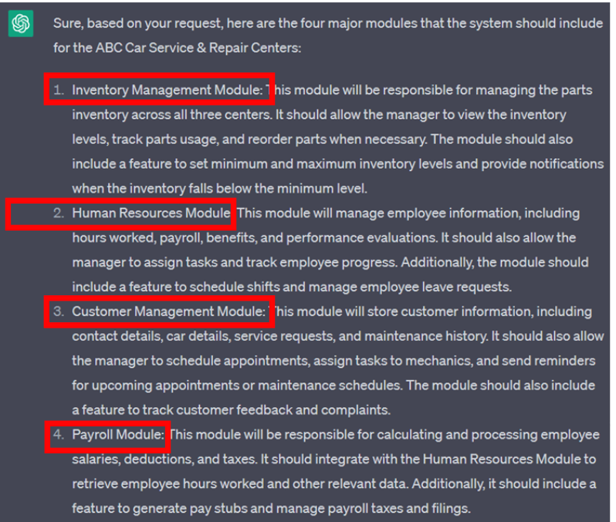

**🡪**Although there is a difference in interpretation, the meaning of both is the same

**c. How will a data dictionary help you develop the system? Give examples.**

([1],25) The data dictionary is a DBMS component that stores metadata—data about data. The data dictionary contains data definitions as well as data characteristics and relationships. ([1],91) The purpose of data dictionary is to ensure that all members of database design and implementation teams use the same table and attribute names and characteristics. So here are some examples :

• Resource for the designer, developers and later on for data operators (employee of ABC services) who can look upon the meaning of any element that has been used in the data dictionary.

• A data dictionary can help avoid data integrity issues and improve the overall data quality in the system if you define rules for data validation and data constraints. Take an example from table 7.3, the P_Code property must be of type varchar with up to 10 characters including numbers and letters

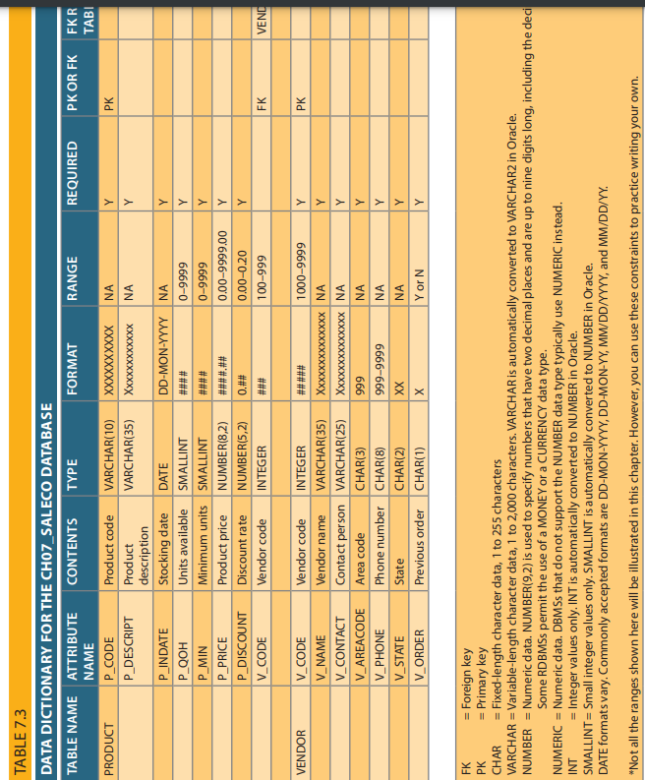

**Compare with ChatGPT :**

**Answer :**

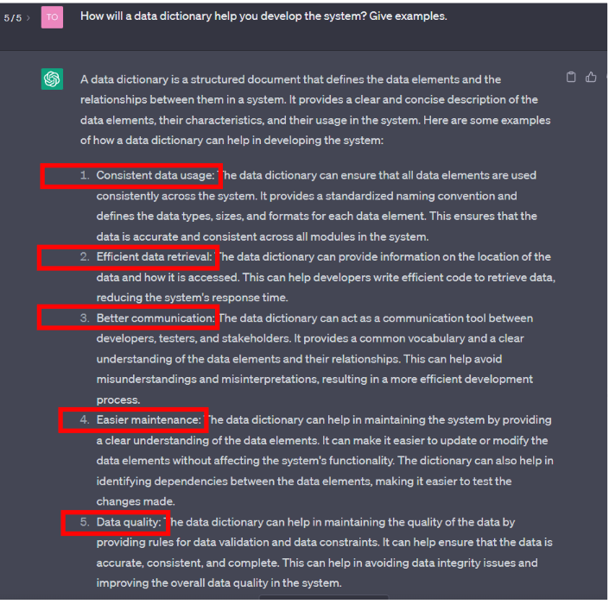

🡪 The results from ChatGPT are more diverse than ours, especially the points 3 and 5 from ChatGPT are the most similar to our results.

**d. What general (system) recommendations might you make to the shop manager? For example, if the system will be integrated, what modules will be integrated? What benefits would be derived from such an integrated system? Include several general recommendations.**

**Answer :**

**Recommendations for the shop manager :**

+ All modules should be integrated because it can automatic update of data between the modules, reducing the need for manual data entry and minimizing errors.

+ Remember to train and support employees on how to use the new system effectively. Providing comprehensive training and support will ensure that the system is properly used, reducing the possibility of errors during use.

+ Separate access rights for each different department, ensuring that only those with a management level or higher can change the data in the database.

**Compare with ChatGPT :**

**Answer :**

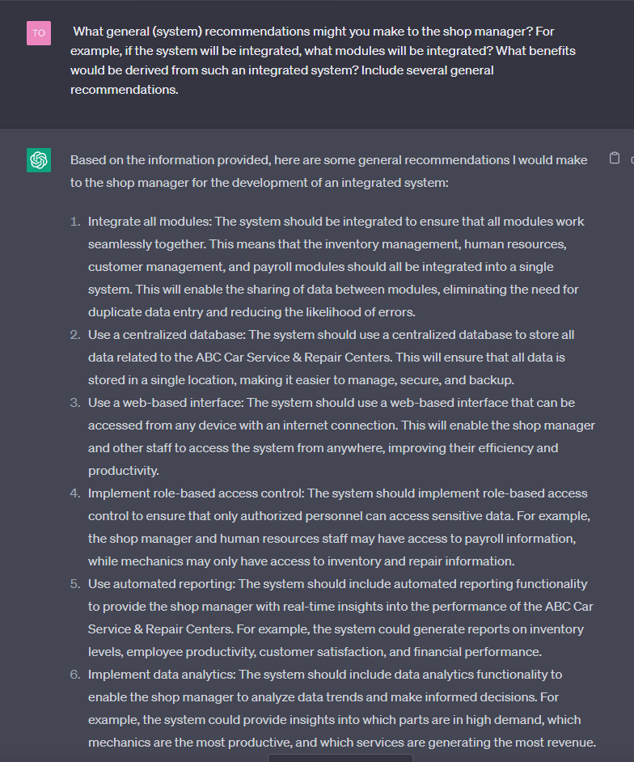

**e. What is the best approach to conceptual database design? Why?**

The best way to develop the conceptual database would be in a centralized database and with a top-down approach.

🡪 The top-down approach is starting with the division of the system into smaller, more manageable components, defining clear goals for each of the system's components, ensuring that all system components are designed to work seamlessly together and ensuring understanding of system requirements.

🡪 Ensuring that all data is stored in a single location, making it easier to manage, secure, and backup ,which would provide better services.

**Compare with ChatGPT :**

**Answer :**

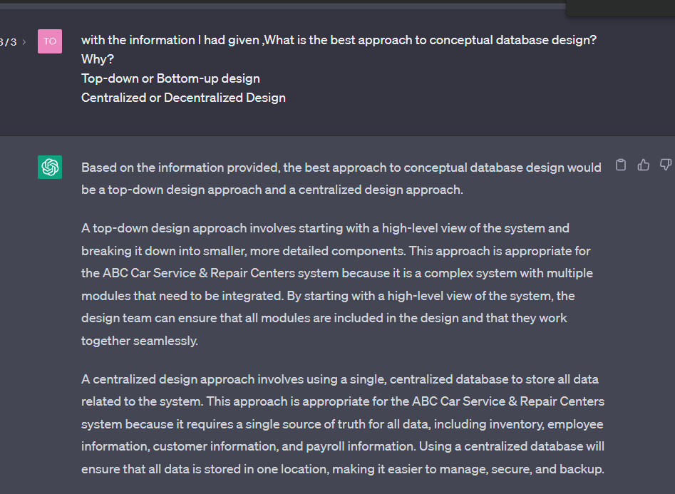

**f. Name and describe at least four reports the system should have. Explain their use. Who will use those reports?**

1. **Payroll report –** The payroll report would be generated monthly and would keep attendance record of all the employees of the company’s station. This would help in deciding the salary to be paid to the employee for that month. Any bonuses or increments may also be applied to that report.

2.**Invoice report –** This report will contain details of all services and products that have been provided by the centers along with sales and revenue statistics.

3. **Customer report –** This report will be generated monthly and will have detailed information about all current customers. The report may contain a list of their previous purchases, account balances, any debt details, and more.

4. **Inventory report –** The inventory report is generated on a monthly basis and will keep information on the quantity of available products and a record of any parts or service purchases made on behalf of the company. InventoryManagement will manage these reports.

**Compare with ChatGPT :**

**Answer :**

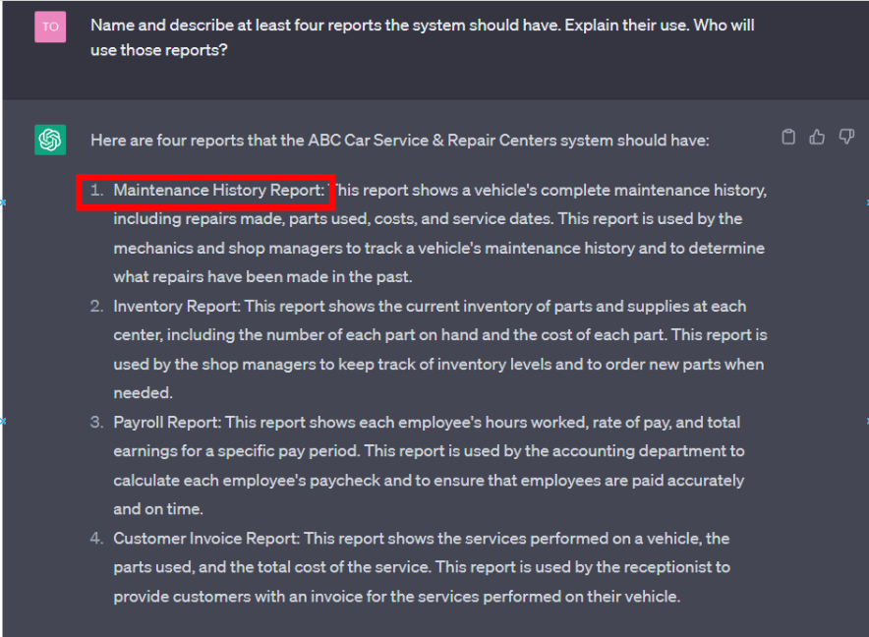

🡪 The results from ChatGPT have a difference in the choice of report type, which is maintenance report and invoice report.

**References :**

[1] Database System Design, Implementation, and Management 12th edition